ISEC2077 : Assignment 3
W0400411
By Mohammad Al Jokhadar

Table of Contents
No table of contents entries found.

You try to open a file, OS establishes a handler in memory, you are able to read/write a file after another event happens ( the handle is 4656 – there is a subcategory to capture the actual file system action of writing)

Event ID 6416 - A new external device was recognized by the system.- may be useful. But if the user has the drive plugged in already, the admin would not get an alert if they have this event ID , which is 6416, as a condition of the alert ( akin to being alerted for both event ids 6416 and 4656 )

Task 1 – Audit Policy Changes
Establish logging on a Windows machine in the lab, a laptop or a VM and use gpedit to set Auditing of the following events.
For each Audit policy change, take a screen shot of the gpedit screen showing the final Audit configuration (i.e. showing that audit Success or Failure box is ticked) for each change to the Audit Policy.

Steps to retrieve Log Events :

In order for us to gather all the Windows Log Events, we launch eventvwr.exe after utilizing Make me Admin to have administrative privileges for a PowerShell terminal, and then navigate to Custom Views in order to collect all the log events pertaining to the following events :

A User account is created
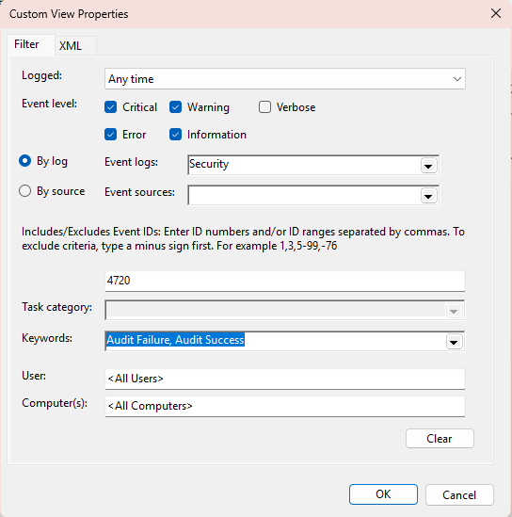
Figure 1- Screenshot showing Event ID 4720 in Event Viewer, indicating a new user account creation
Event ID/s:
4720
Description :
This policy would alert the administrator of the creation of a new user file.
Reasoning :
Audit Failures and Audit Success were selected due to the importance of knowing all attempts pertaining to the creation of new user account. Furthermore, the Critical, Warning, Error and Information Event Levels were selected to have logs pertaining the creation of new accounts albeit of the log event’s criticality level.

“Windows Security Log Event ID 4720 - A User Account Was Created.” Accessed November 4, 2025. https://www.ultimatewindowssecurity.com/securitylog/encyclopedia/event.aspx?eventid=4720.

An Account Failed to Log on
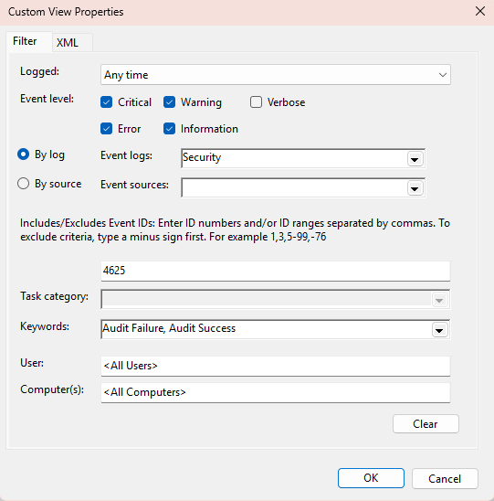
Figure 2 - Screenshot of Event ID 4625, capturing a failed login attempt due to incorrect credentials
Event ID/s:
4625
Description :
This policy would alert the administrator of each failed login attempt on the system. The event log would provide the account that made the login request.
Reasoning :
Audit Failures and Audit Success were selected due to the importance of knowing all failed login attempts. Furthermore, the Critical, Warning, Error and Information Event Levels were selected to have all the logs pertaining to failed logon attempts regardless of the criticality level.

“Windows Security Log Event ID 4625 - An Account Failed to Log On.” Accessed November 5, 2025. https://www.ultimatewindowssecurity.com/securitylog/encyclopedia/event.aspx?eventid=4625.

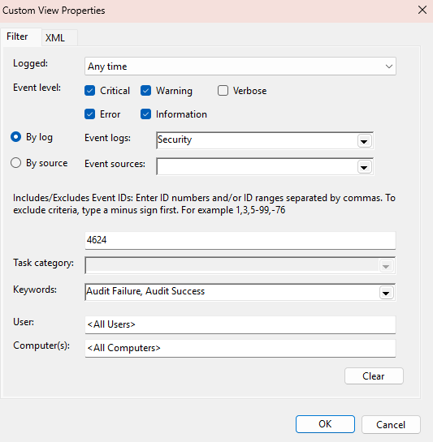
An Account has successfully Logged in :
Figure 3 - Screenshot of Event ID 4624, showing a successful user logon event
Event ID/s:
4624
Description :
This policy would alert the administrator of each successful login attempt on the system. The event log would provide the account that made the login request.
Reasoning :
Audit Failures and Audit Success were selected due to the importance of knowing all failed login attempts. Furthermore, the Critical, Warning, Error and Information Event Levels were selected to have all the logs pertaining to failed logon attempts regardless of the criticality level.

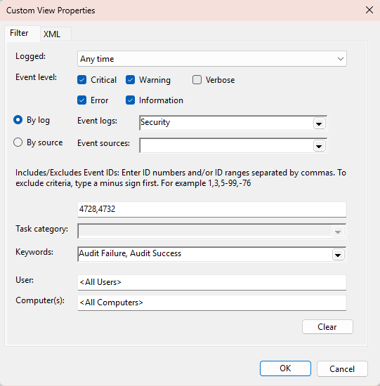
A User has been added to an Administrator group
Figure 4 - Screenshot showing a user being added to a security-enabled group, indicating privilege escalation

Event ID/s:
4728,4732

Description :
This policy would alert the administrator of events pertaining to the addition of a new member to a security-enabled global and local groups. This is significant due to the elevation of privilege that is being granted to the new member. Both events in question, in terms of local and global security-enabled groups, would provide the name of the user, name of the group, and the name of the computer as parts of a log entry.
Reasoning :
Audit Failures and Audit Success were selected due to the importance of knowing all failed privilege escalation attempts. Furthermore, the Critical, Warning, Error and Information Event Levels were selected to have a complete picture of across the different levels of criticality.
Windows Security Log Event ID 4728—A member was added to a security-enabled global group. (n.d.). Retrieved November 6, 2025, from https://www.ultimatewindowssecurity.com/securitylog/encyclopedia/event.aspx?eventid=4728
Windows Security Log Event ID 4732—A member was added to a security-enabled local group. (n.d.). Retrieved November 6, 2025, from https://www.ultimatewindowssecurity.com/securitylog/encyclopedia/event.aspx?eventid=4732

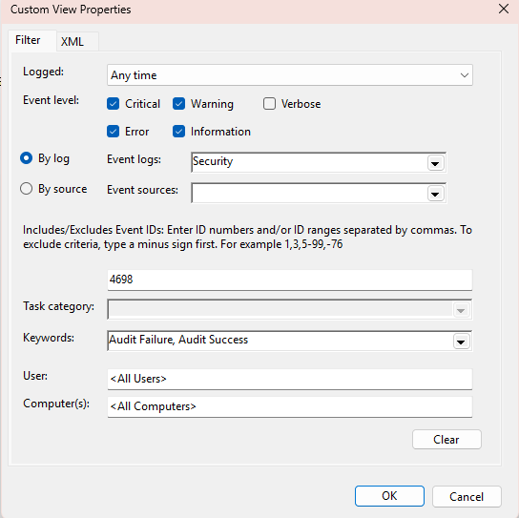
A New Scheduled Task has been created
Figure 5 - Screenshot of Event ID 4698, showing the creation of a new scheduled task by the user

Event ID/s:
4698
Description :
This policy would alert the administrator of events pertaining to the creation of a new scheduled task.

It will provide the name of the user, the task name, and the path to the Task Scheduler application as parts of a log entry.
Reasoning :
Audit Failures and Audit Success were selected due to the importance of knowing all failed and successful attempts. Furthermore, the Critical, Warning, Error and Information Event Levels were selected to have a complete picture of across the different levels of criticality.

Windows Security Log Event ID 4698—A scheduled task was created. (n.d.). Retrieved November 6, 2025, from https://www.ultimatewindowssecurity.com/securitylog/encyclopedia/event.aspx?eventid=4698

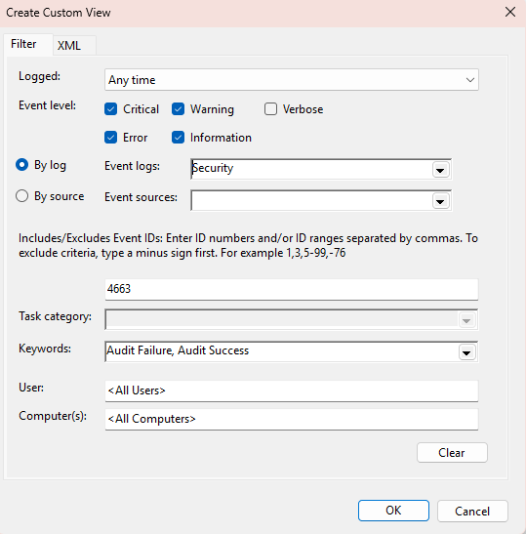
File written to external storage
Figure 6 - Screenshot of Event ID 4663, capturing access to a USB device and file write operation
Event ID/s:
4663
Description :
This policy would alert the administrator of events pertaining to attempts to access an object, which would be in this case the USB drive.
Reasoning :
Audit Failures and Audit Success were selected due to the importance of knowing all failed and successful attempts. Furthermore, the Critical, Warning, Error and Information Event Levels were selected to have a complete picture of across the different levels of criticality.
Windows Security Log Event ID 4663—An attempt was made to access an object. (n.d.). Retrieved November 6, 2025, from https://www.ultimatewindowssecurity.com/securitylog/encyclopedia/event.aspx?eventid=4663

File written to external storage
Event ID/s:
4663
Description :
This policy would alert the administrator of events pertaining to attempts to access an object, which would be in this case the USB drive.
Reasoning :
Audit Failures and Audit Success were selected due to the importance of knowing all failed and successful attempts. Furthermore, the Critical, Warning, Error and Information Event Levels were selected to have a complete picture of across the different levels of criticality.
Windows Security Log Event ID 4663—An attempt was made to access an object. (n.d.). Retrieved November 6, 2025, from https://www.ultimatewindowssecurity.com/securitylog/encyclopedia/event.aspx?eventid=4663

Change of Audit Policies

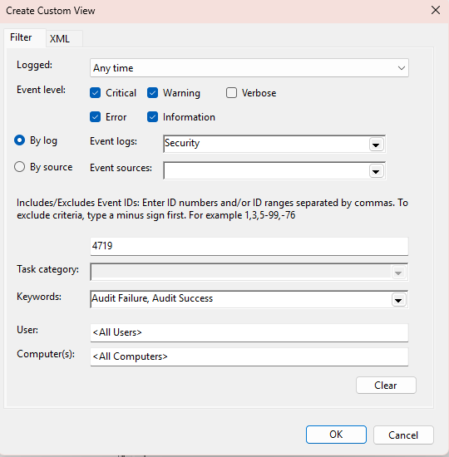
Event ID/s:
4719
Figure 7 - Screenshot of Event ID 4719, showing a change in the system audit policy
Description :
This policy would alert the administrator of events pertaining to changes in a System Audit Policy.
Reasoning :
Audit Failures and Audit Success were selected due to the importance of knowing all failed and successful attempts. Furthermore, the Critical, Warning, Error and Information Event Levels were selected to have a complete picture of across the different levels of criticality.

Windows Security Log Event ID 4719—System audit policy was changed. (n.d.). Retrieved November 6, 2025, from https://www.ultimatewindowssecurity.com/securitylog/encyclopedia/event.aspx?eventid=4719

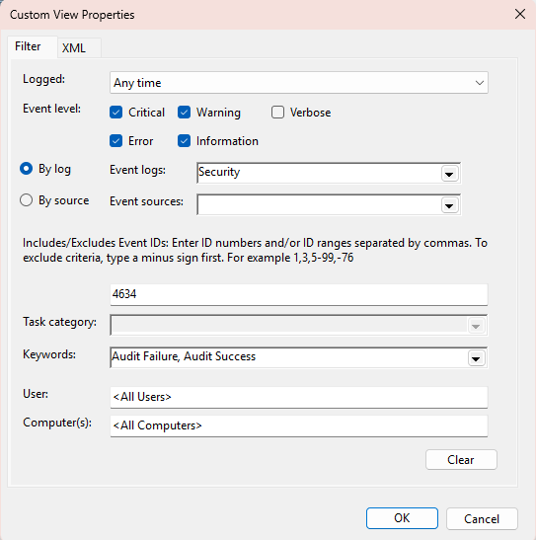
User Logs off
Figure 8 - Screenshot of Event ID 4634, indicating that a user has logged off the system

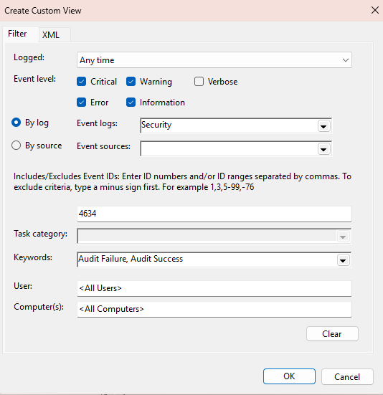
Event ID/s:
4634
Description :
This policy would alert the administrator of events pertaining to a user logging off.
Reasoning :
Audit Failures and Audit Success were selected due to the importance of knowing all failed and successful attempts. Furthermore, the Critical, Warning, Error and Information Event Levels were selected to have a complete picture of across the different levels of criticality.

Windows Security Log Event ID 4634—An account was logged off. (n.d.). Retrieved November 6, 2025, from https://www.ultimatewindowssecurity.com/securitylog/encyclopedia/event.aspx?eventid=4634

Steps to enable auditing :

Launch gpedit.msc after utilizing Make me Admin to have administrative privileges for a PowerShell terminal, and then navigate to :
Computer Configuration à Windows Settings à Security Settings à Advanced Audit Policy Configuration à System Audit Policies – Local Group Policy Object

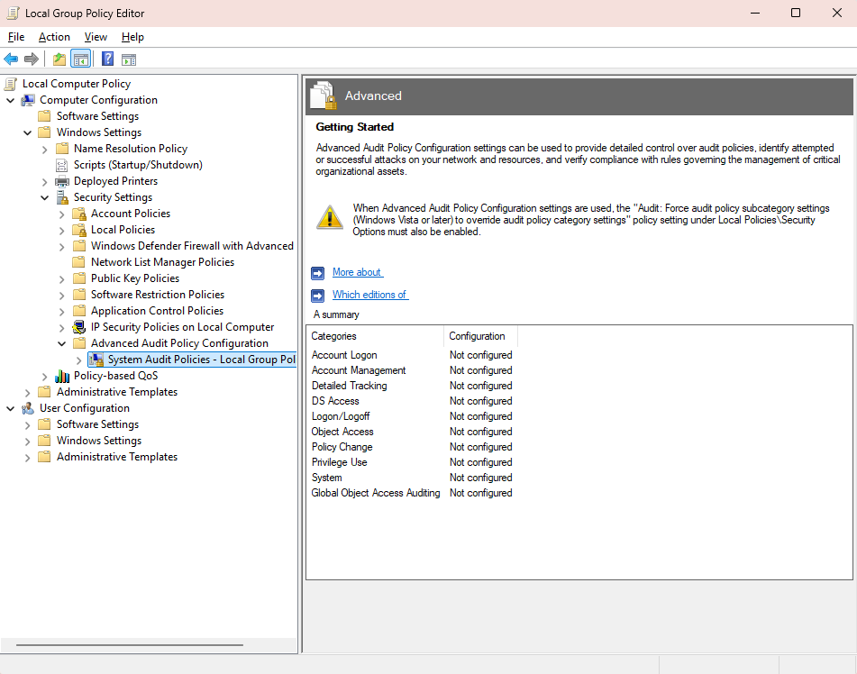
Here we see many different avenues for auditing! Let us proceed …

Account Management --> Audit User Account Management :
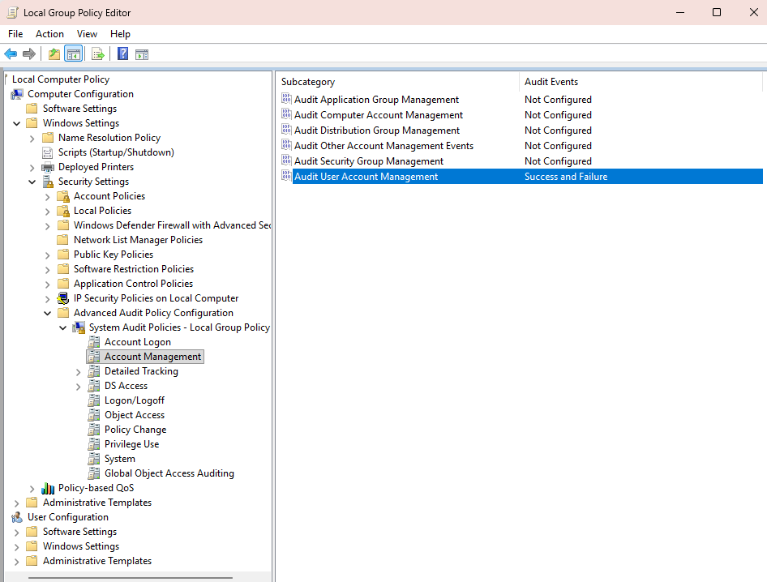

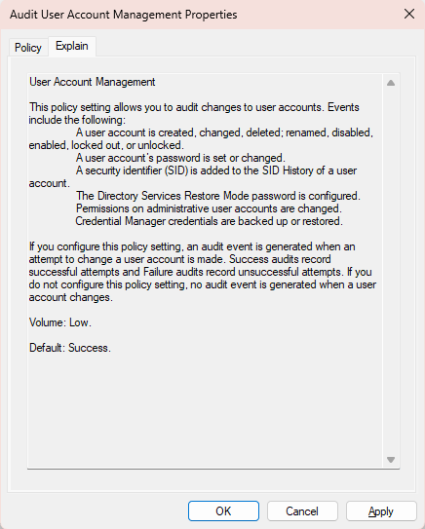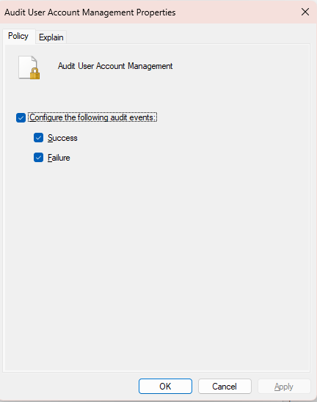
Figure 9 - Group Policy Editor showing audit settings for User Account Management
Significance:

... followed by Logon/Logoff --> Audit Logon :

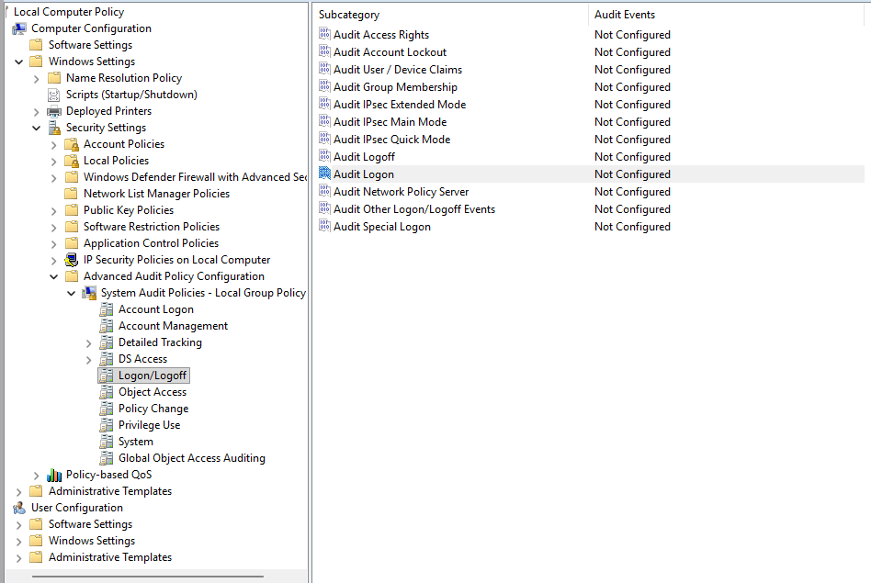

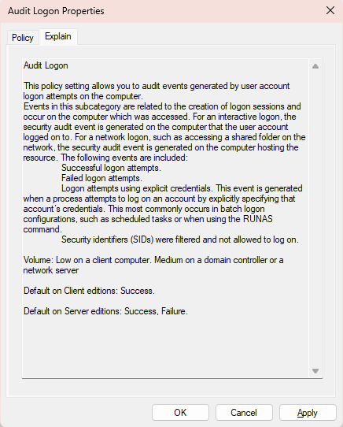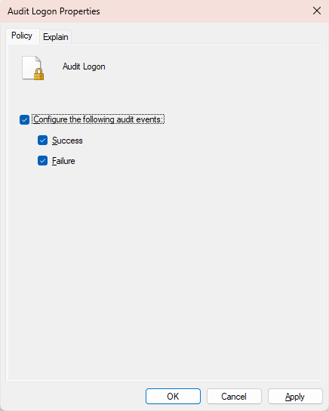
Figure 10 - Group Policy Editor showing audit settings for Logon events
Significance:
... followed by Logon/Logoff --> Audit Logoff :
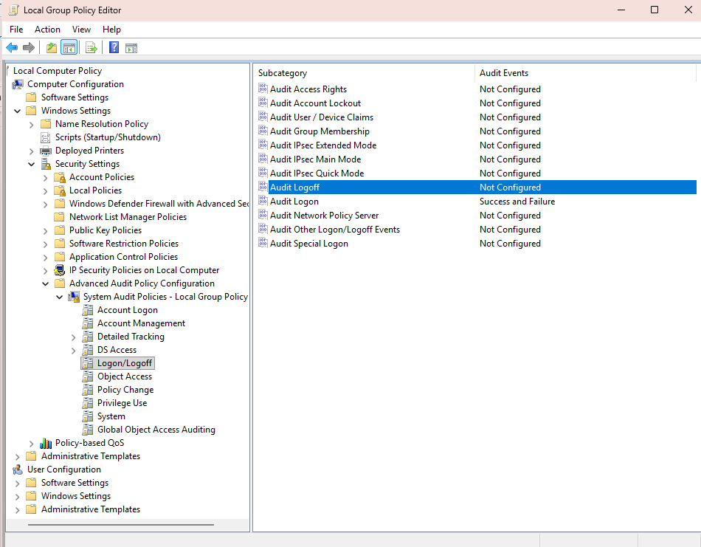
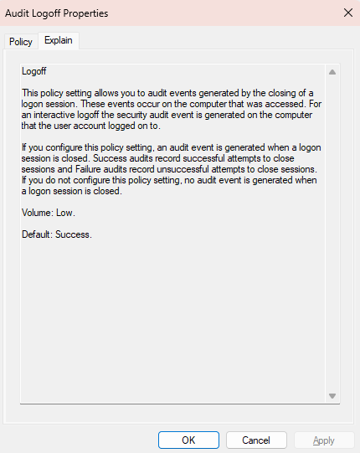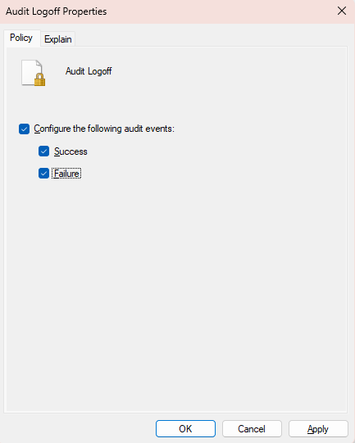
Figure 11 - Group Policy Editor showing audit settings for Logoff events
Significance:

Next, we shift to the Policy Change --> Audit Audit Policy Change:

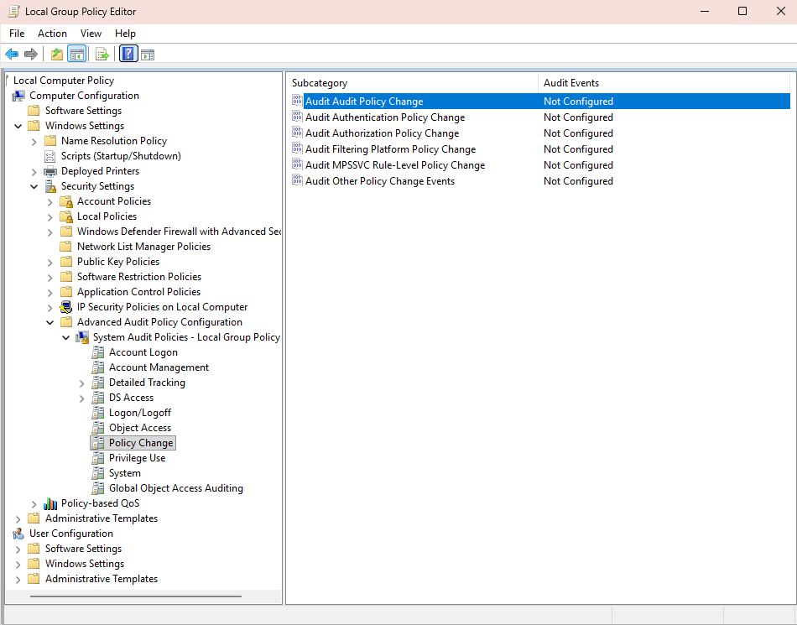
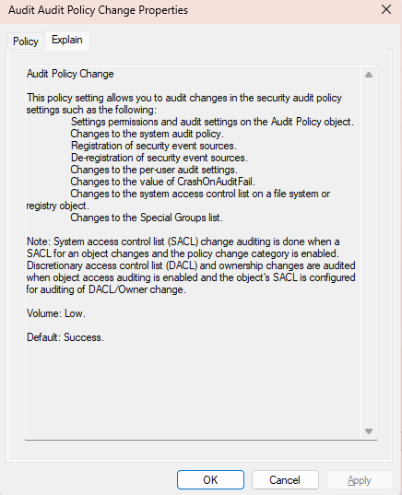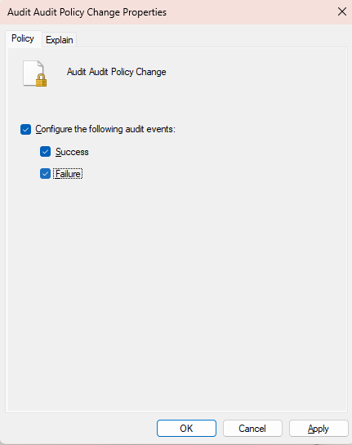
Figure 12 - Group Policy Editor showing audit settings for changes to audit policies
Significance:

Next, we shift to the Object Access --> Audit Removable Storage:
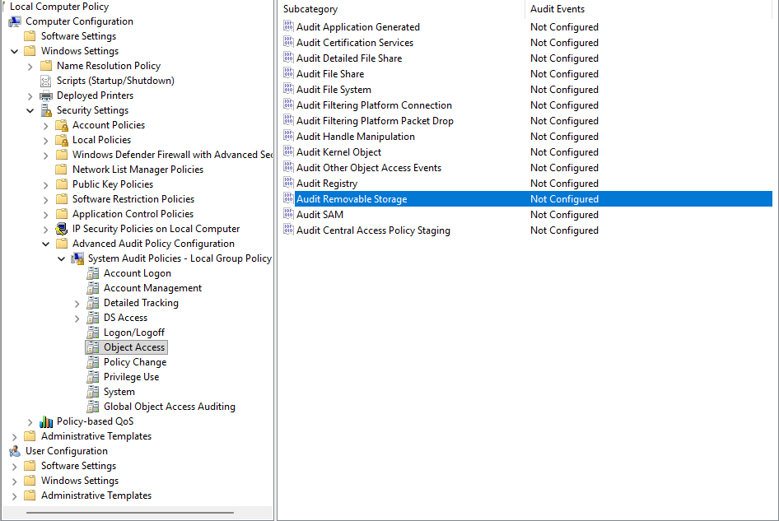

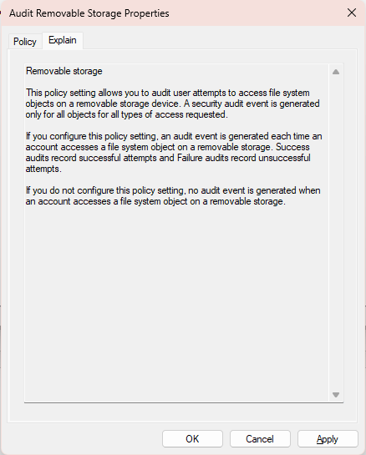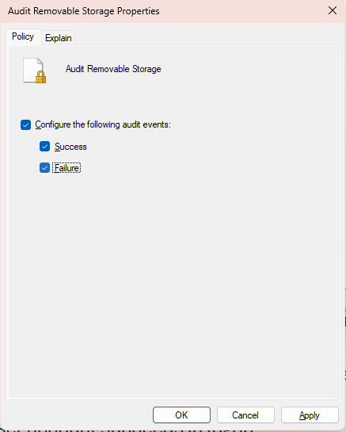
Figure 13 - Group Policy Editor showing audit settings for removable storage access
Significance:

... followed by Logon/Logoff --> Audit Account Lockout :

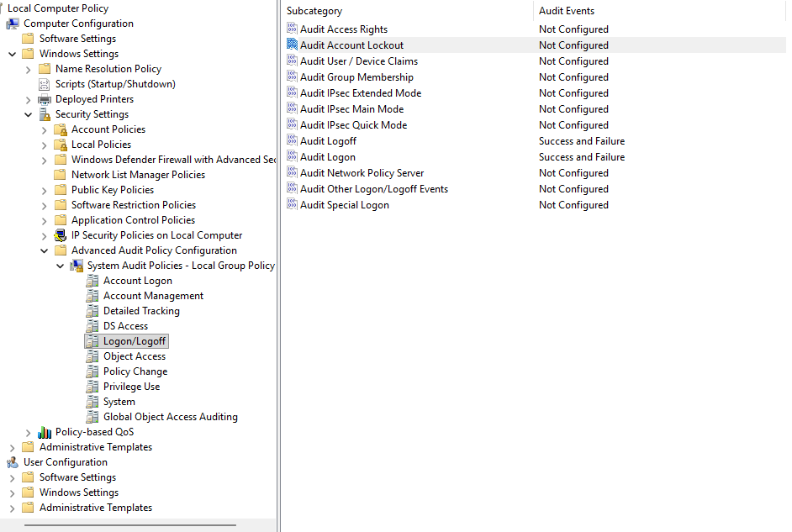
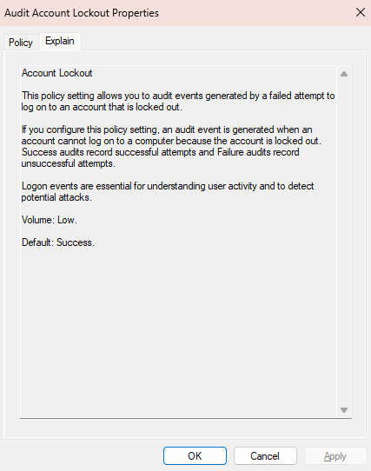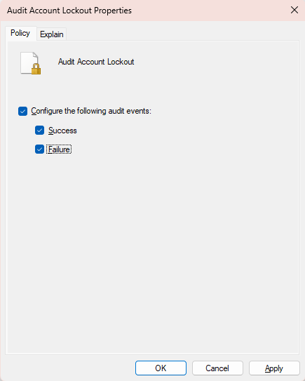
Figure 14 - Group Policy Editor showing audit settings for account lockout events

Significance:

… finally, I have opted to Audit Group Membership to track down any attempts to add the local user to the security-enabled groups :

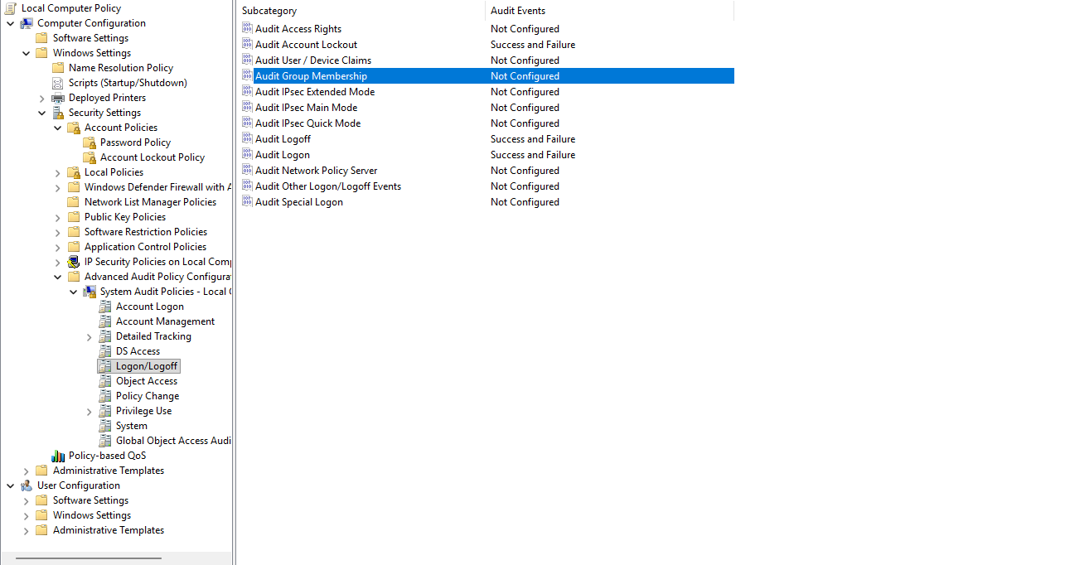
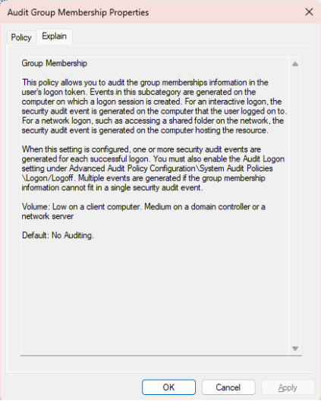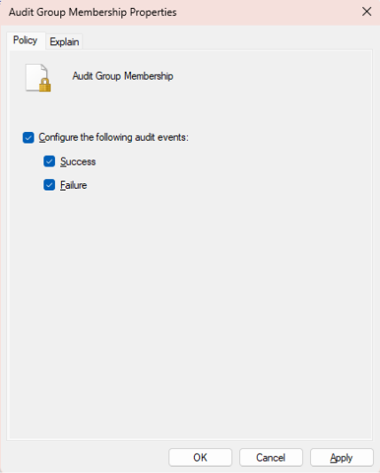
Figure 15 - Group Policy Editor showing audit settings for group membership changes

Significance:

Task 2 – Event Creation
Create the following events such that are captured in the Windows Logs.
1. A User account is created (Use this account for the following steps).
2. User account fails to login due to an incorrect password.
3. User account succeeds in logon.
4. User account is made a member of the administrators group.
5. User account creates a scheduled task.
6. User account accesses a USB key or other external storage media and writes a file to the device.
7. User account makes a change to an Audit Policy (i.e. stop logging failed logon attempts).
8. User account logs out.
Task 3 – Event Display
Use event viewer to display these events you have created. Take screen shots of each event as required
to show the detail of events displayed in event viewer (not just a list of the events) such that you can
clearly read the event information.
Create a word (PDF) document that contains the screen shots described above. Label each screen shot
in the document with a description of what it is showing.

References

“Windows Security Log Event ID 4720 - A User Account Was Created.” Accessed November 4, 2025. https://www.ultimatewindowssecurity.com/securitylog/encyclopedia/event.aspx?eventid=4720.

“Windows Security Log Event ID 4625 - An Account Failed to Log On.” Accessed November 5, 2025. https://www.ultimatewindowssecurity.com/securitylog/encyclopedia/event.aspx?eventid=4625.

